India is a land of varied cultures and traditions. Diversities in all spheres make the Indian culture quite unique. Indian folk and tribal dances are product of different socio-economic set up and traditions evolved over ages. In India, we have festivals and celebrations virtually every day, and dances are performed to express joy and festivity. This has added to the richness of Indian culture. Since every festival is accompanied by celebration, folk dances have become an integral part of our social milieu. There are numerous folk and tribal dances, and almost all of them have continuously evolved. dances are performed for every possible occasion - to celebrate the arrival of seasons, birth of a child, a wedding and festivals, which are a plenty. The folk dances are extremely simple with minimum of steps or movement. Indian folk dances are full of energy and vitality. Some dances are performed separately by men and women while in some performances men and women dance together. Folk dances are created by individuals to depict the lifestyles of people in a specific country or region. These dances are not all ethnic dances, they are not ceremonial dances or dances based on Asian countries and some European nations like Portugal, everything ranging from cuisine to culture has had its share of impact. Folk dances though have been largely untouched as their origin predates the invasion of these countries. Hence, getting to know about these dances becomes utmost important as they narrate the story of aboriginals, in the most artistic way possible

**INDIAN FOLK DANCE**

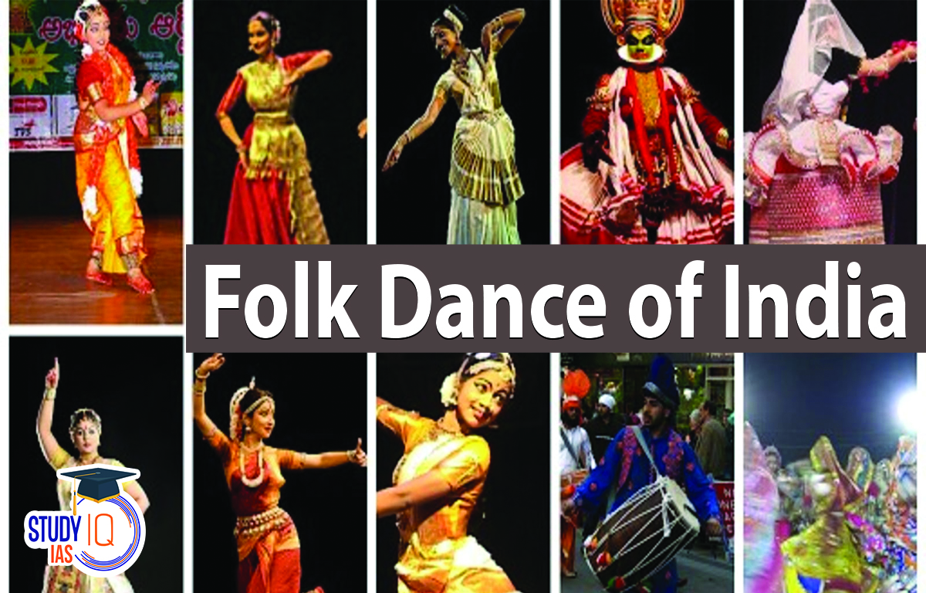

[Grab your reader’s attention with a great quote from the document or use this space to emphasize a key point. To place this text box anywhere on the page, just drag it.]